**Module (Bootstrap Basic & Advanced) – 6**

1. What are the advantages of Bootstrap?

Ans :

* **Easy to use:** Anybody with just basic knowledge of HTML and CSS can start using Bootstrap
* **Responsive features:** Bootstrap's responsive CSS adjusts to phones, tablets, and desktops
* **Mobile-first approach:** In Bootstrap 3, mobile-first styles are part of the subcore framework.

2. What is a Bootstrap Container, and how does it work?

Ans :

Containers are used to pad the content inside of them, and there are two container classes available:

1. The .container class provides a responsive **fixed width container**
2. The .container-fluid class provides a **full width container**,spanning the entire width of the viewport



3. What are the default Bootstrap text settings?

Ans :

* Font Family: Bootstrap sets the default font family to be the system's default sans-serif font
* Font Size: The base font size is set to 16 pixels (px) by default.
* Line Height: The default line height for body text is set to 1.5, providing adequate spacing between lines for readability.
* Text Color: The default text color is defined as **#212529**, a dark shade of gray
* Text Alignment: Bootstrap sets text alignment to left by default for most elements.

4. What do you know about the Bootstrap Grid System?

Ans :

Bootstrap’s grid system uses a series of containers, rows, and columns to layout and align content. It’s built with flexbox and is fully responsive.

The Bootstrap 5 grid system has six classes:

* .col- (extra small devices - screen width less than 576px)
* .col-sm- (small devices - screen width equal to or greater than 576px)
* .col-md- (medium devices - screen width equal to or greater than 768px)
* .col-lg- (large devices - screen width equal to or greater than 992px)
* .col-xl- (xlarge devices - screen width equal to or greater than 1200px)
* .col-xxl- (xxlarge devices - screen width equal to or greater than 1400px)

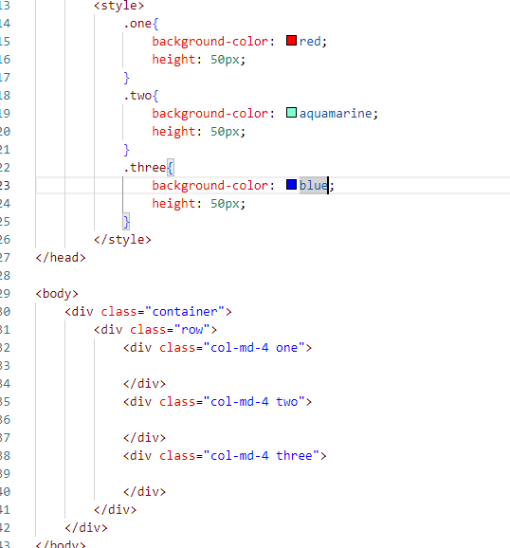

Output:

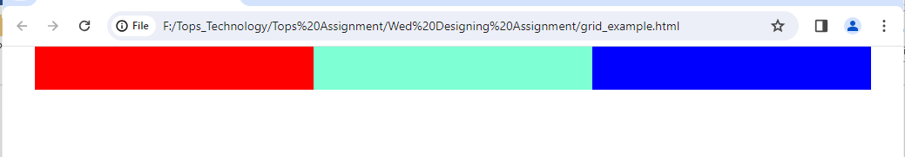

5. What is the difference between Bootstrap 4 and Bootstrap 5?

Ans :

|  |  |  |
| --- | --- | --- |
| **BASIS OF** | **BOOTSTRAP 4** | **BOOTSTRAP 5** |
| Grid System | It has 5 tier (xs, sm, md, lg, xl). | It has 6 tier (xs, sm, md, lg, xl, xxl). |
| Color | It has limited colors. | Extra colors added with the looks, A card improved color palette. there are various shades available to choose. |
| Jquery | It has jquery and all related plugins. | Jquery is removed and switched to vanilla JS with some working plugins |
| Navbar | We have inline-block property and we will get white dropdown as default for dropdown-menu-dark class. | Inline-block property is removed and we will get black dropdown as default for dropdown-menu-dark class. |
| Static Site Generator | Bootstrap 4 uses Jekyll software. | Bootstrap 5 uses Hugo software as it is fast static site generator. |
| Bootstrap Icons | Bootstrap 4 doesn’t have its own SVG icons, we have to use font-awesome for icons. | Bootstrap 5 have its own SVG icons |

6. What is a Button Group, and what is the class for a basic Button Group?

Ans :

Button Groups in Bootstrap is a class of name “btngroup” which is used to create series of buttons in groups (without spaces) vertically or horizontally. This is the basic syntax of the button group class where each button has its own class of “btn”.

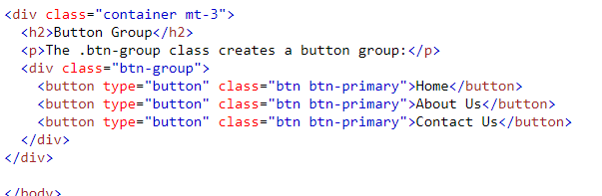

Output :

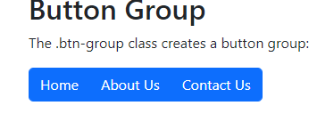

7. How can you use Bootstrap to make thumbnails?

Ans :

Bootstrap – Thumbnails

1. Add an <a> tag with the class of . thumbnail around an image.

2. This adds four pixels of padding and a gray border.

3. On hover, an animated glow outlines the image.

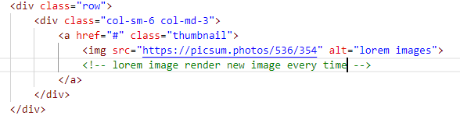

Output:

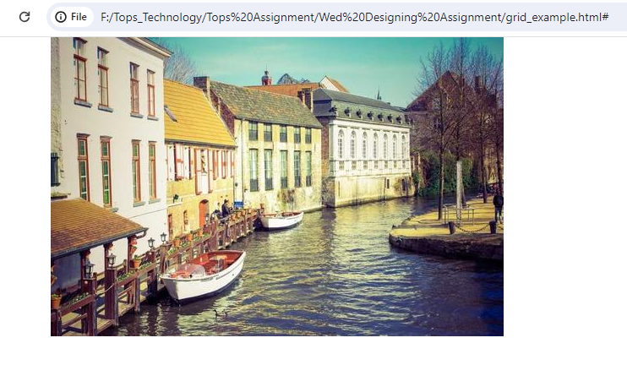

8. In Bootstrap 4, what is flexbox?

Ans :

Use flex classes to control the layout of Bootstrap 4 components.

The Flexible Box Layout Module, makes it easier to design flexible responsive layout structure without using float or positioning.

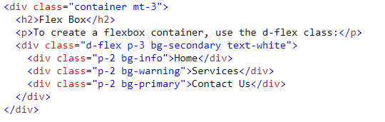

Output:

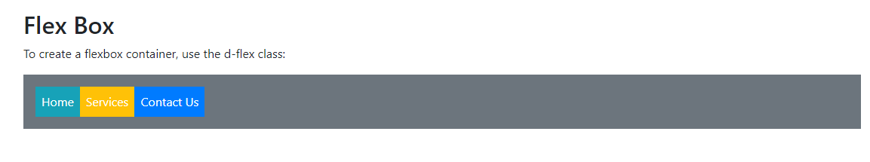

9. How can one create an alert in Bootstrap?

Ans :

Provide contextual feedback messages for typical user actions with the handful of available and flexible alert messages.

Code:

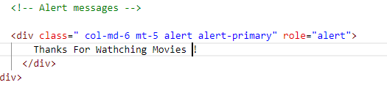

Output:

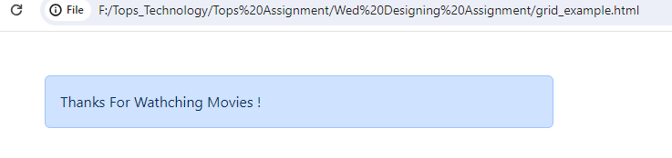

10. What is a bootstrap card and how would you create one?

Ans :

A card is a flexible and extensible content container. It includes options for headers and footers, a wide variety of content, contextual background colors, and powerful display options.

Code:

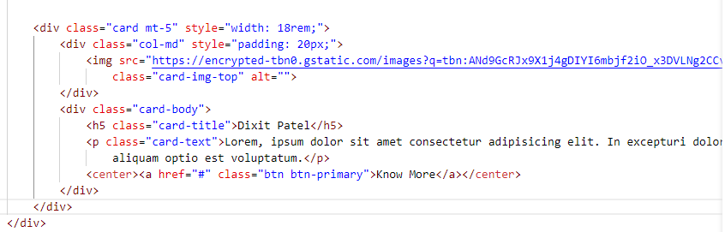

Output:

